Background

Acoustic radiation is traditionally produced through the vibration of diaphragms or solid flat surfaces which can then be transferred to solids, gases and liquids by a variety of means but which are all based on some type of acoustic coupling. The acoustic source is always produced at a source point, be it a diaphragm, crystal or surface and this source, when coupled through a coupling medium, will radiate from a relatively small point to the often large surrounding environment in some preferrd direction, which is dependent on the position and orientation of the vibration source a spherical manner when permitted, be it gaseous, fluid or solid. Due to this very broad and mainly spherical cone shape form radiation of acoustic vibration, vibrational power dissipates relatively quickly with the propagation distance in countless directions. So as to better focus and direct acoustic radiation for many applications, a “Horn” configuration is applied so as to focus the vibrational energy from the source point to within a certain angle or cone direction.

When attempting to cause evenly distributed vibration specifically in long 1D or wide 2D areas or large 3D volumes, all traditional acoustic emitters today have a relatively low efficiency of acoustic power transfer into the required area or volume and well defined shape or uniformity of ultrasonic energy distribution as described above. Uni-directional type acoustic emitters are all associated with problems of relatively restricted area or volume coverage which can further be detrimentally effected by unrelated movements within the gaseous or fluidic environment under investigation, through flow, waves and other such unforeseen force.

A method which could create uniform distribution of acoustic energy in gases, liquids and solids within well defined space in 1D, 2D and 3D is highly desired.

Summary

An innovative device is proposed for the efficient and effective production and transmission of acoustic vibrations within gases, liquid and gels. The device is based on the acoustic activation of a long wire, tube or rod, which is then capable of transmitting radial, bending, axial and longitudinal vibrations within the gaseous, liquid or gel medium or environment. Through transfer of energy using a variety of acoustic waves forms from a “primary transducer” to another “secondary transducer”, and which are commonly fixed in a perpendicular and 90-degree construction, waves are created and transferred to an infinite number of points along the secondary transducer’s length.

By creating infinite points of vibration along the complete length of a long wire, tube or rod (several meters to 100’s of meters), it is now possible to effectively and efficiently transfer acoustic energy to the surrounding environment be it gaseous, liquid or gel, in an extremely effective manner. Furthermore, the straight wire, tube or rod transducers may be arranged in a multitude in such a way so that the effective active zone encompassing each of the transducers, overlap to form a new and combined, and active, 2D area or 3D volume. In addition, the wire, tube or rod transducers may be deformed by bending so as to form 2D or 3D structures, which will also create acoustically active 2D areas and 3D volumes within its gaseous, liquid or gel environment.

Claims

1. A method for generating large-scale acoustic vibration in air or liquid medium such as oil or water or gels wherein the first acoustic transducer generates a longitudinal motion and at the end of this transducer a metallic wire, tube or rod of various design, which is fixed perpendicular to the direction of movement of the first transducer, generates a transverse or bending movement in the direction of longitudinal movement of the first transducer and propagates acoustic vibration radially into the surrounding medium, with a predominant propagation direction in the longitudinal movement of the first transducer,
characterized in that the first acoustic transducer is firmly bound with a second acoustic transducer (e.g. a wire) and the simple longitudinal movement is transferred into a transverse movement in the second acoustic transducer (Figure 1) or (according to Figure 2) longitudinal and transverse movement of the transducer (2) are simultaneously transferred into the transducer (1), (Figure 2), so that the transducer ( 1) produces an acoustic vibration in the surrounding medium throughout its complete length and throughout a large volume or area of the medium.

2. A method according to claim 1, characterized in that the second transducer (1) is firmly bound by a fixed physical contact at 90 degrees to the first transducer (2) and the longitudinal motion of this first transducer is transferred into transverse motion within the second transducer, and an overall new transducer, as a combination of transducers (2) and transducers (1), is acting as the vibrational source, specifically along the entire length of the transducer (1) which is considered to be the main source of vibration for the surrounding medium (Figure 1), or the transducer (1), outlined in Figure 2, absorbs all modes of vibration from the transducer (2) both longitudinally and transversely (Figure 2) and the linear transducer (1) radiates all of these modes of vibration into the environment.

3. Method according to one of the preceding claims 1 or 2, characterized in that the second transducer (1) of a line-formed wire, tube or rod with the entire length (L), preferably cylindrical with a diameter of a few millimeters to a few centimeters, vibrates transversely and with negligible absorption and further vibrates transversely, and together with transducer (2) to form a new line-shaped vibration source.

4.A method according to claim 3, characterized in that each point on the line-shaped wire, tube or rod acts as a new point source of the vibration radiating acoustic energy radially into the surrounding medium such that along the wire, tube or rod there forms a cylindrical acoustic zone of activation with a cross-section S. (Figure 1) or R. (Figure 2)

5. A method according to claim 4, characterized in that a medium is vibrated within the acoustic zone, which is propagated by the action of the acoustic line-shaped vibration source, and vibrates at a similar vibration frequency, and the radial range of the acoustic zone depends on the vibration intensity of the line-shaped vibration source, and the absorption of the acoustic energy along the radial direction limits the size of the real and overall active zone.

6. A method according to claim 5, characterized in that the surrounding medium (such as air, gas, water or any liquid) can be applied by the linear acoustic transducers with homogeneous distributed acoustic energy and well-defined oscillation frequency in a given space or volume.

7. A method according to claim 6, characterized in that the shape of the acoustic zone is given by the deformation (bending) of the line-shaped vibration source, the effective acoustic zone can be produced as one-dimensional (6), two-dimensional (7) or three-dimensional (8) forms (Figure 3)

8. A method according to claim 6, characterized in that the shape of the acoustic zone is given through a combination of 2 or more straight line-shaped vibrational sources producing two-dimensional (9) or three-dimensional (10) forms (Figure 4)

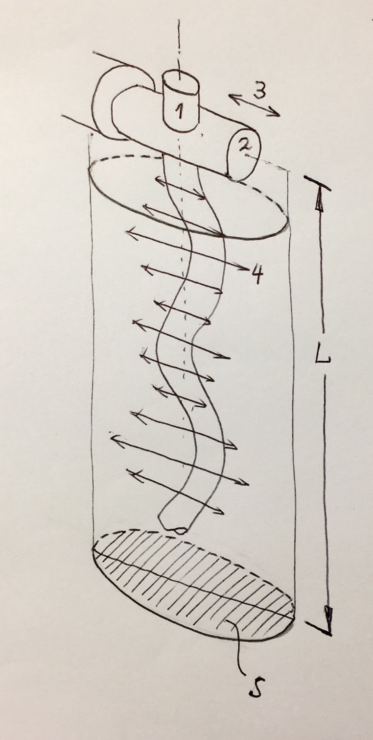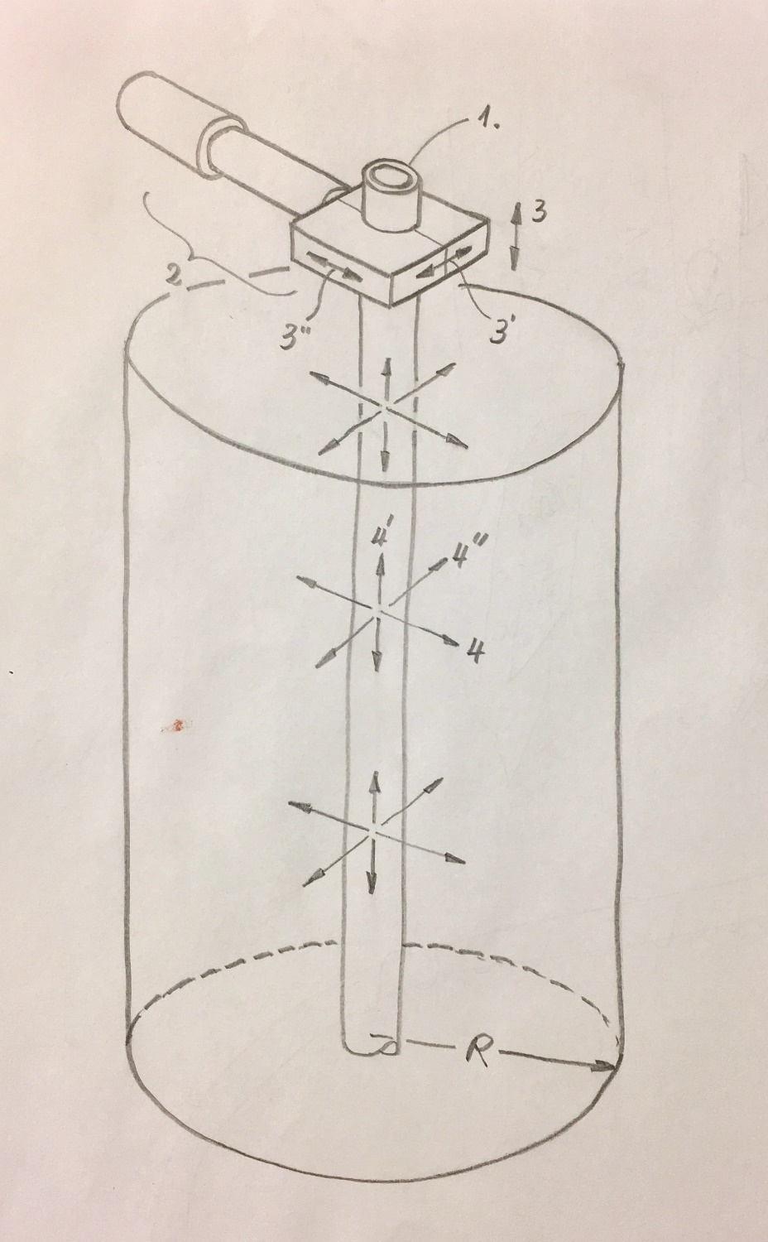
Figure 1. Figure 2.

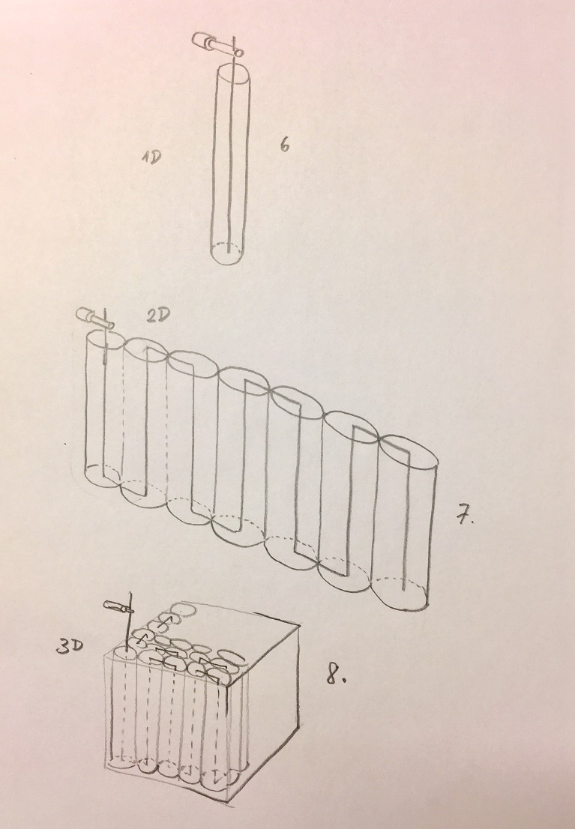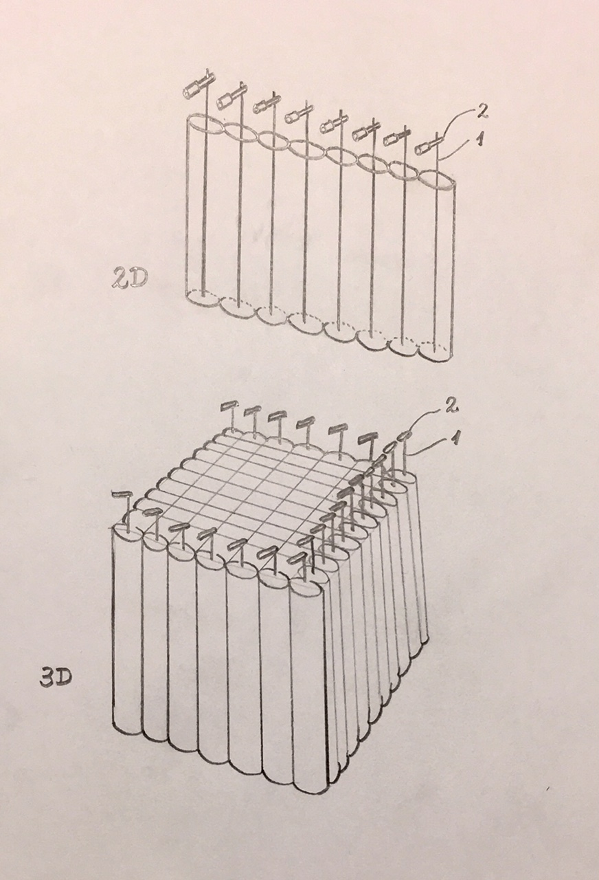
Figure 3. Figure 4.

